**Spring MVC Framework**

## The DispatcherServlet

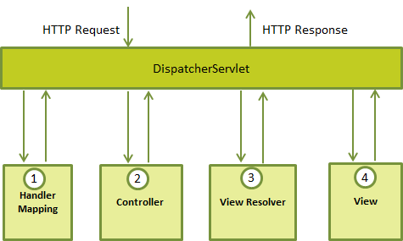

Web.xml**:[** *Loctaion webapp/WEB-INF]*

<web-app id="WebApp_ID" version="2.4"

xmlns="http://java.sun.com/xml/ns/j2ee"

xmlns:xsi="http://www.w3.org/2001/XMLSchema-instance"

xsi:schemaLocation="http://java.sun.com/xml/ns/j2ee

http://java.sun.com/xml/ns/j2ee/web-app_2_4.xsd">

<display-name>Spring MVC Application</display-name>

<servlet>

<servlet-name>HelloWeb</servlet-name>

<servlet-class>

org.springframework.web.servlet.DispatcherServlet

</servlet-class>

<load-on-startup>1</load-on-startup>

</servlet>

<servlet-mapping>

<servlet-name>HelloWeb</servlet-name>

<url-pattern>*.jsp</url-pattern>

</servlet-mapping>

<context-param>

<param-name>contextConfigLocation</param-name>

<param-value>/WEB-INF/Servlet-context..xml</param-value>

</context-param>

<listener>

<listener-class>

org.springframework.web.context.ContextLoaderListener

</listener-class>

</listener>

</web-app>

Orange configuration required :

The **web.xml** file will be kept *WebContent/WEB-INF* directory of your web application. OK, upon initialization of **HelloWeb** *DispatcherServlet*, the framework will try to load the application context from a file named **[servlet-name]-servlet.xml** located in the application's *WebContent/WEB-INF* directory. In this case our file will be **HelloWeb-servlet.xml**.

Next, <servlet-mapping> tag indicates what URLs will be handled by the which DispatcherServlet. Here all the HTTP requests ending with **.jsp** will be handled by the **HelloWeb** DispatcherServlet.

**Servlet-context.xml:[** *Loctaion webapp/WEB-INF or same as provided with* contextConfigLocation]

<beans xmlns="http://www.springframework.org/schema/beans"

xmlns:context="http://www.springframework.org/schema/context"

xmlns:xsi="http://www.w3.org/2001/XMLSchema-instance"

xsi:schemaLocation="

http://www.springframework.org/schema/beans

http://www.springframework.org/schema/beans/spring-beans-3.0.xsd

http://www.springframework.org/schema/context

http://www.springframework.org/schema/context/spring-context-3.0.xsd">

<context:component-scan base-package="list all pacakges " />

<bean class="org.springframework.web.servlet.view.InternalResourceViewResolver">

<property name="prefix" value="/WEB-INF/content/ />

<property name="suffix" value=".jsp" />

</bean>

</beans>

## Defining a Controller[src pacakage]

@Controller

public class HelloController{

@RequestMapping(value = "/hello", method = RequestMethod.GET)

public String printHello(ModelMap model) {

model.addAttribute("message", "Hello Spring MVC Framework!");

return "hello";

}

}

**Creating JSP Views[same as provided with view resolver ie** /WEB-INF/content/**] hello.jsp**

<html>

<head>

<title>Hello Spring MVC</title>

</head>

<body>

<h2>${message}</h2>

</body>

</html>

# Spring MVC Form Handling Example

# Spring Exception Handling Example